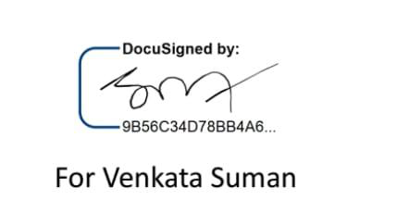

01-05-2023

Dear PEUGU MITHILESH CHARAN SAI,

**Subject: Internship Offer letter**

Dear Mithilesh,   
We would like to congratulate you on being selected for an internship with **Redefine Career**.

Your internship is scheduled to start effective from **01 May 2023** for a period of 3 months. As such, your internship will include training/orientation and focus primarily on learning and developing new skills and gaining a deeper understanding of concepts through hands-on application of the knowledge you learned in class.

Again, congratulations and we look forward to working with you.

Best Regards,

Venkat Suman,   
CEO, Redefine Career

--------------------------------------------------------------------------------------

|  |  |
| --- | --- |
|  | REDEFINE CAREER PRIVATE LIMITED  Reg. Off. : 001, 9th Cross, 11th Main, HAL 2nd Stage, Bangalore - 560038. |